Project Description:

Curly Maple Mini Bookshelf Speakers with Accent

Design Goals:

- Accurate and clean sound reproduction
- Extended low end despite the small size of the enclosure
- Small enough to fit on a narrow shelf
- Visually appealing (if not eye-catching)

While sitting in my office one day, in between jobs, it occurred to me how ironic is was that I had no permanent speakers in my office for listening for my listening pleaseure. I spend the majority of my time in my small office designing speakers when not in the shop fabricating, finishing or assembling speakers. Space is at a premium. There is barely enough room for my desk, electronic bench, file cabinet and a wall covered with books, and not much else. I checked my inventory to see what I had on hand to work with and a few days later music filled my office.

Driver Selection:

The focus of the design was to design and build small two-way speakers having a supportive low frequency response despite its modest size. I am a fan of the ND series of drivers has they typically have larger than typical excursion as well as good power handling capability for their size. For this build I chose the ND105-8. It provides more than adequate frequency response in the lower end given is size and mass. Their look is clean and simple allowing the cabinet’s design to pop.

For the high end, I used the Peerless XT25SC90-04, featuring a 22 mm voice coil mounted in a neodymium motor. This is a good choice for many 2-way speaker applications. It has relatively good off-axis response producing a bright sounding high end without being harsh. Despite its modest price and looks, it handles a lot of power (100 watts rms). The only real detractor are the solder tabs. They are molded into the plastic body requiring you to be fast at soldering because the tabs and the surrounding plastic will melt if disconnect crimps are not used.

Enclosure Design:

The enclosure design is relatively simple as it required no complex baffling. The four sides were fabricated with solid cherry wood. The front baffle is made of curly maple with an added accent stripe made of some exotic strips of wood I had laying around the shop. The back panel is stained 3/16” plywood to accommodate the 1” port and terminal cup.

The inner chamber dimensions are 12 1/4” x 7 5/8” x 4 3/4” for a volume of ~0.235 ft³. The port dimensions are 1” diameter x 4”. This configuration yielded an Fb of 44.8 Hz, further boosting the low end.

Enclosure Assembly:

The front baffles were fabricated from a solid piece of curly maple. These were then bisected at random angles on the table saw. Thin strips of Movingui, African Padauk, and Wenge were laminated together to serve as an accent stripe on the front baffle. The accent piece was then glued between the two maple pieces of each front baffle. Since I compromised the strength of the baffle with the accent stripe, it was glued to a 1/4” piece of maple for structural support. This additional layer was thankfully hidden by the large rubber surround of the speaker. Holes for the drivers was cut using a router and a circle cutting jig and the edges of the woofer holes where chamfered with using a chamfer bit.

The corner joints are miter joints for visual appeal. To accommodate for wood expansion, the front baffle is about 1/8” undersize with the edges rounded over to visually minimize the gap between the front baffle and the edges of the enclosure. The front baffle is secured to the enclosure using silicon caulking rather than wood glue, again to accommodate the movement from wood expansion in the humid months.

Because the miter joint is an end-grain joint, ½” gussets running the length of the joint were glued to the interior of each joint providing strength/rigidity to an otherwise questionable joint. An alternative could have been to use remaining accent stripping for splines in the joint itself (but that would have required building another jig for the table saw and more time).

The finish is a sprayed gloss polyurethane, 3 layers.

Crossover Design:

The tweeter uses a 3rd-order Butterworth filter design while the woofer used a 2nd order Butterworth. Both drivers require some equalization in order to achieve a somewhat flat response. The tweeter’s higher frequencies tend to increase in volume as seen in the frequency response graph below. Thankfully, those frequencies tend to become in audible as they increase. Still an L-Pad was required to tame tweeter down and flatten the frequency response a bit. The ND105-8 had a sharp peak in the frequency spectrum at about 3200 Hz requiring equalization to flatten it out as well. The final crossover is depicted in the graphic and schematic below.

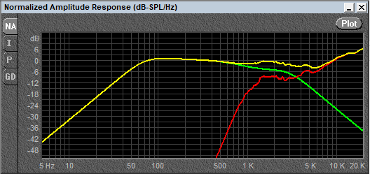

Here is the schematic for the crossover as well as the values of each component.

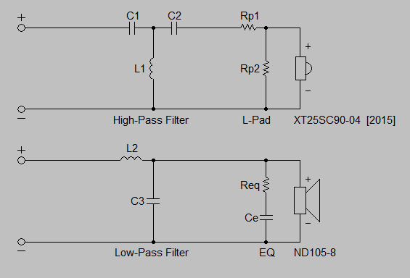

Tweeter |  | Woofer
C1 | 5 µF | L2 | 0.75 mH
C2 | 10 µF | C3 | 5 µF
L1 | 1 mH | Req | 10 Ω
Rp1 | 10 Ω | Ce | 22 µF
Rp2 | 2 Ω

Products Used

264-1014 | Peerless by Tymphany XT25SC90-04 1" Dual Ring Radiator Tweeter
290-214 | Dayton Audio ND105-8 4" Aluminum Cone Midbass Driver 8 Ohm
027-432 | Dayton Audio DMPC-5.1 5.1uF 250V Polypropylene Capacitor
027-428 | Dayton Audio DMPC-10 10uF 250V Polypropylene Capacitor
027-120 | Audyn Cap Q4 22uF 400V MKP Metalized Polypropylene Foil Crossover Capacitor
225-240 | Jantzen Audio 0.75mH 18 AWG Air Core Inductor Crossover Coil
257-826 | Dayton Audio 1.0mH 18 AWG Perfect Layer Inductor Crossover Coil
004-2 | Dayton Audio DNR-2.0 2 Ohm 10W Precision Audio Grade Resistor
004-10 | Dayton Audio DNR-10 10 Ohm 10W Precision Audio Grade Resistor
260-282 | Parts Express Pressfit Speaker Terminal Cup 2-1/4" Gold Banana Binding Post
260-470 | Speaker Cabinet Port Tube 1" ID x 4" L Flared

Conclusion:

The build was fairly straightforward. As with all my designs, they must accurately reproduce sound and look as good as they sound. This one hit on all goals/objectives. The sound reproduction is excellent with a full but not overpowering low end, small footprint, and they are eye-catching.

Tips and Tricks:

Take your time when making miter joints. Everything must be perfect and orthogonal in order to avoid any external gaps in the joint. To accomplish this, I used an Incra Miter1000se miter gauge with telescoping fence to maintain perfect registration during cutting operations.

Butt joints are quicker, easier and stronger, but look cheap so that was not an option. Another joinery option still appealing and very strong are finger joints, but again that would require more time and material to make a fixture for cutting the fingers of the joint.

To cut clean and centered holes for the drivers in any speaker I highly recommend using a Jasper 200J Model 200 circle cutting jig for plunge router. Warning, the 200J is a very delicate piece of thin plastic mounted to a relatively heavy router. Because of all the registration holes in the fixture it WILL snap in two if you’re not careful setting it down. When setting the router down after cutting a hole, make sure the router end of the two, not the far of the plastic fixture, contacts the surface first or the jig will snap and you will spend another $40 to replace it.

